# Relational Databases and SQL Course 2020-2021

Home Exercise 5

Answer the following questions and include your SQL code in each answer.

1. Create a non-updatable view on one or more of the tables in the sakila database. Explain why it is non-updatable. Give your view a good, clear name.
2. Run the below query against the sakila database, then click the Execution Plan button in the Workbench. What does the plan show?

SELECT * FROM customer

WHERE email LIKE 'S%';

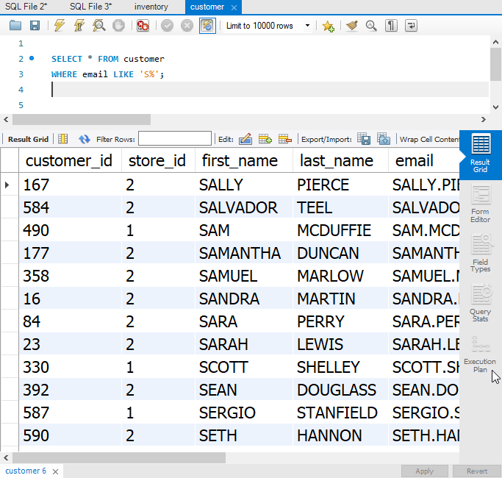

1. Add a new index (key) to the customer table so that the above query runs faster.
2. Now run the query again and examine the Execution Plan again. What has changed?  
     
   *PS – Hover your mouse over the execution plan diagram to see interesting details about the execution of the query.*

*This last question is based on the WITH ROLLUP operator. We will learn about it in lesson 13 so do not worry about it until after the lesson.*

1. Write a query that targets the payment table in sakila and lists for every customer

how much money they paid every month.

Use the WITH ROLLUP operator to also show the amount each customer paid overall (sum of amounts for all months).   
  
Make sure your table also prints one final row showing the total amount of money paid by all customers over the entire table.

Below is how the end of the result set from your query should look like.

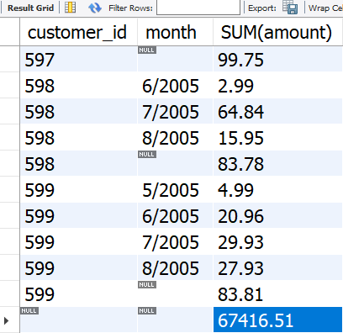

Good luck!

* EOF -